**1.Title: Personal Health Management Web Application**

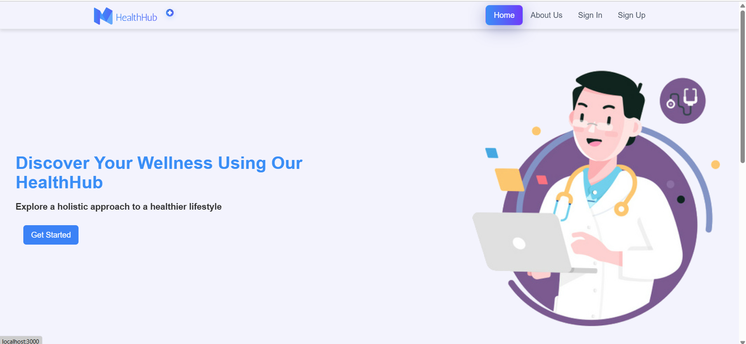

**2.Project Statement:**

The project aims to develop a web application that allows users to manage their health through features like tracking physical metrics, diet, exercise, and mental health. The platform will offer users personalized insights and recommendations based on their logged data to help them achieve better health outcomes.

**Outcomes:**

* Simplified health management process for users.
* Improved user awareness of health status and progress.
* Flexibility in setting and tracking health-related goals.
* Enhanced overall health outcomes through personalized insights.

1. **Modules to be implemented**

* User Authentication and Registration
* Health Metrics Tracking
* Nutrition Analysis
* Exercise Tracking
* Stress Management

**Week-wise module implementation and high-level requirements with output screenshots**

**Learning Phase: Weeks 1-5**

* **Week 1**: **Spring Framework** – Introduction to Spring, Spring Boot, and dependency injection.
* **Week 2**: **Microservice Architecture** – Understanding microservices, REST API development, and communication between services.
* **Week 3**: **Security** – Introduction to JWT-based authentication and role-based access control.
* **Weeks 4-5**: **React Development** – Introduction to React, component-based design, and front-end integration with Spring Boot backends.

**Project Implementation Phase: Weeks 6-7**

**Module 1: User Authentication and Registration**

* Implement user registration functionality.
* Develop user login mechanism.
* Output screenshot:

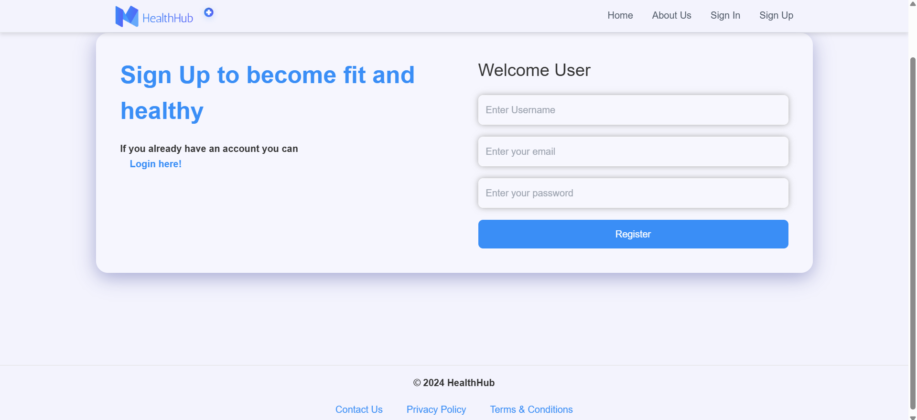

**Module 2: Health Metrics Tracking**

* Design and develop an interface for tracking health metrics like weight, blood pressure, heart rate, and water intake.
* Allow users to set health-related goals such as target weight or daily water intake.
* Output screenshot:

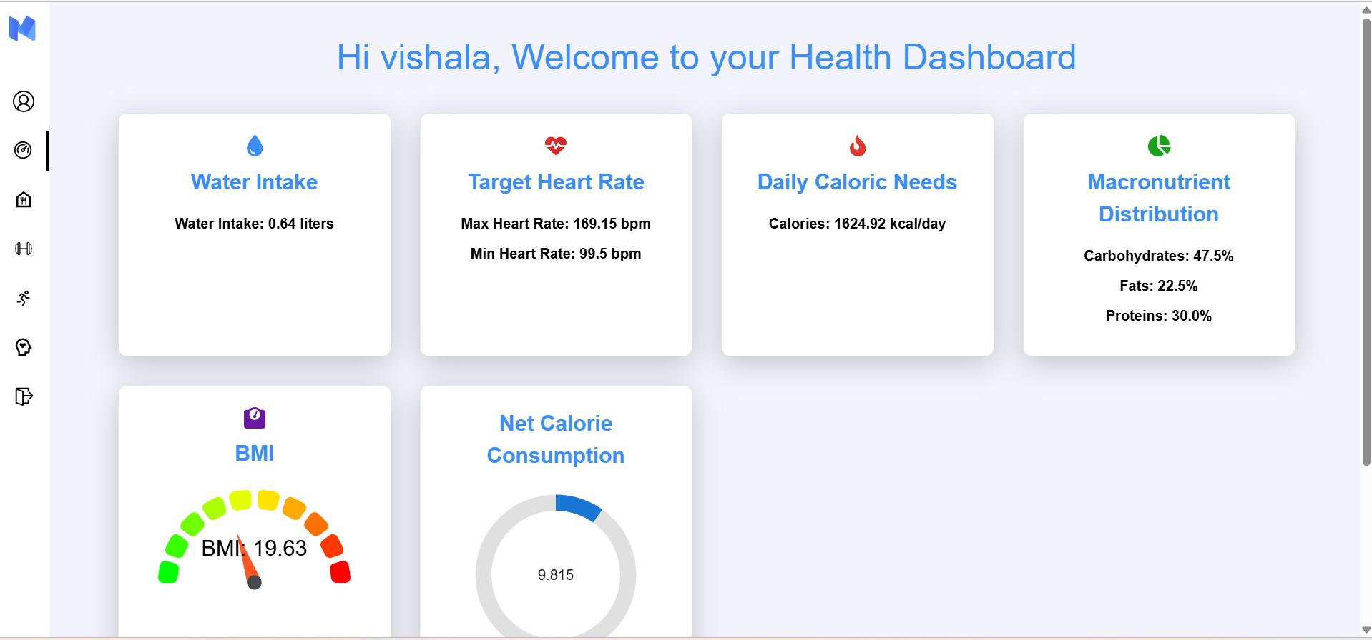

**Module 3: Nutritional Analysis**

* Design an interface for logging meals, tracking nutrition, and planning diets based on health goals.
* Integrate external APIs (like EDAMAM) to analyse nutritional content of meals and provide daily recommendations.
* By clicking on Recommend a Diet Plan based on user details we will get a diet recommendations.
* Output screenshot

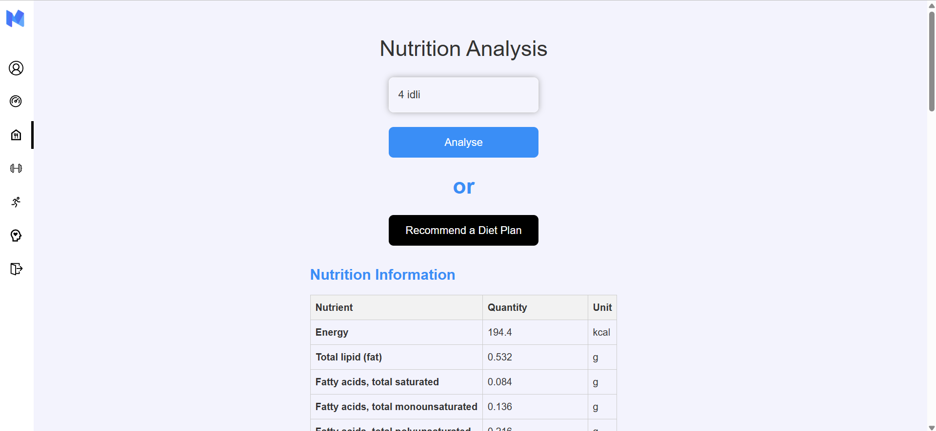

**Module 4: Exercise Tracking**

* Implement a system for users to log exercise activities, estimate calorie burn, and receive personalized exercise recommendations.
* Use external APIs (like the ExerciseDB) to recommend exercise routines.
* Output Screenshot:

**Module 5: Stress Management**

* Allow users to input stress-related details and receive recommendations for relaxation techniques.
* Provide visualized insights into their mental health progress and stress levels.
* Output Screenshot:

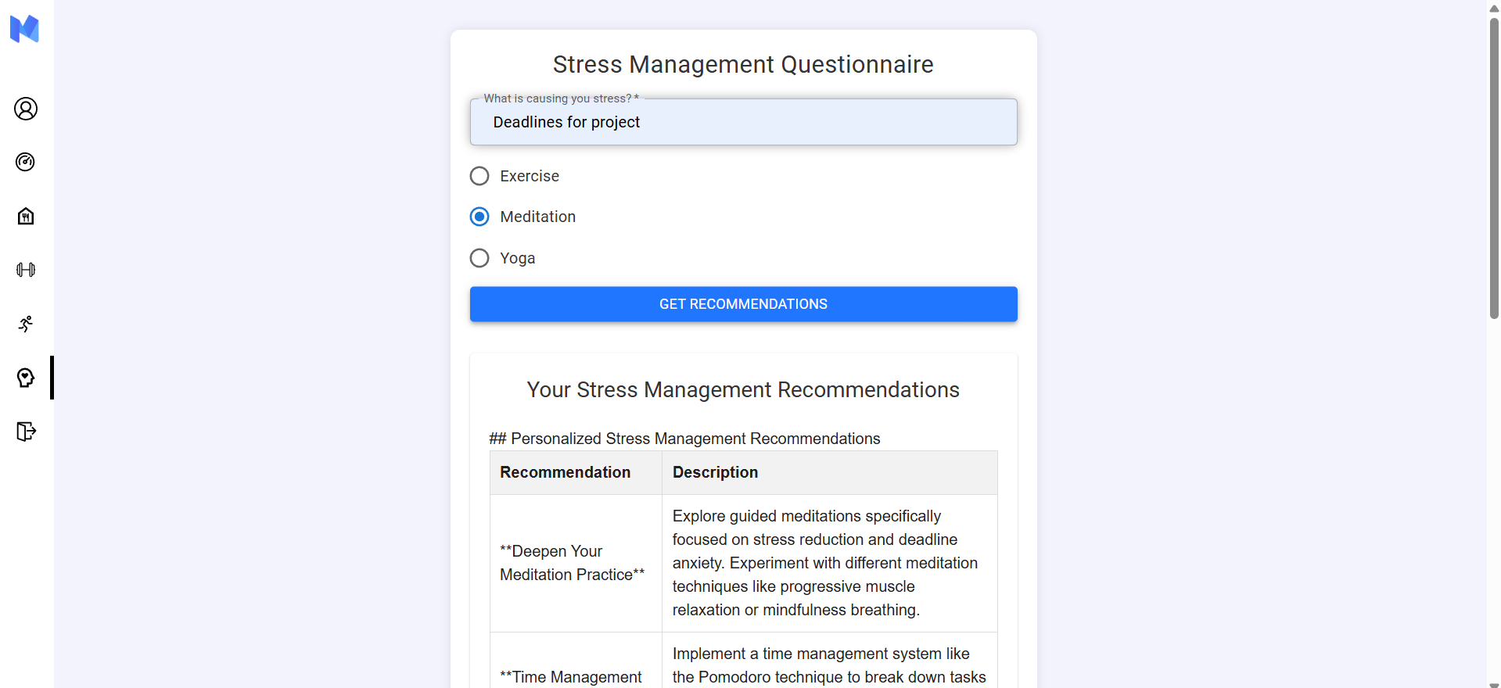

**Evaluation Criteria:**

**Milestone 1 Evaluation:**

* Completion of user authentication and registration. Basic health profile management implemented.

**Milestone 2 Evaluation :**

* Health metrics tracking system is fully developed and integrated with the backend.

**Milestone 3 Evaluation :**

* Diet management module operational with meal logging and nutritional analysis. Exercise tracking system integrated.

**Milestone 4 Evaluation :**

* Stress management, reporting, and admin dashboard are fully implemented and functional.

**Design diagrams**

Class Diagram: Entity classes

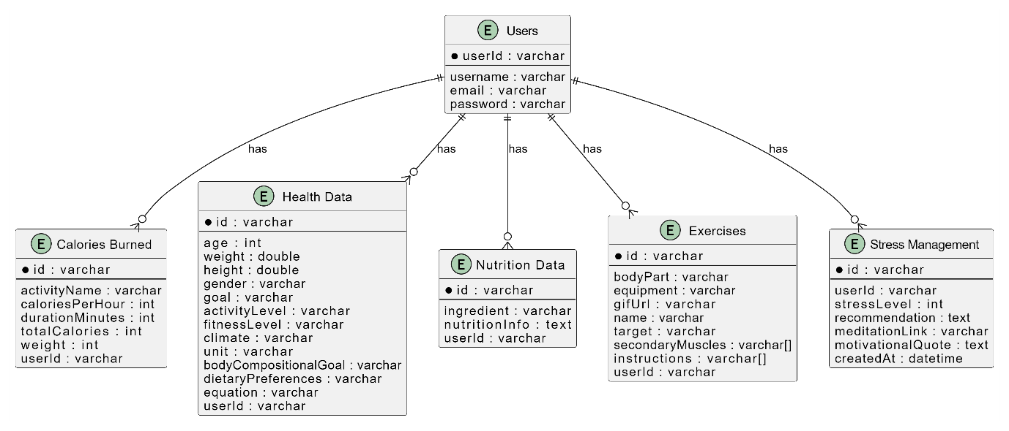

Class Diagram: Service Interface

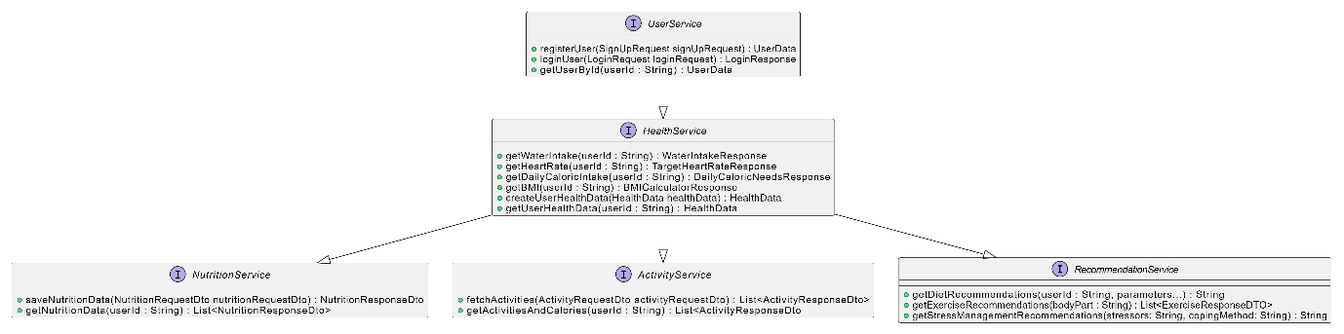

Class Diagram: Repository

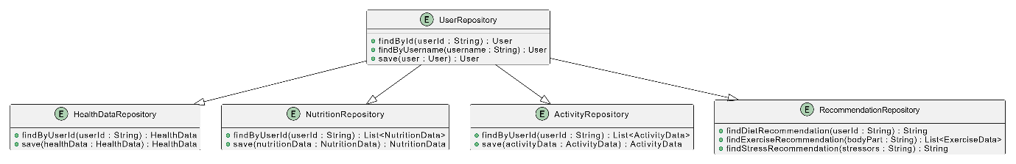

Database Schema

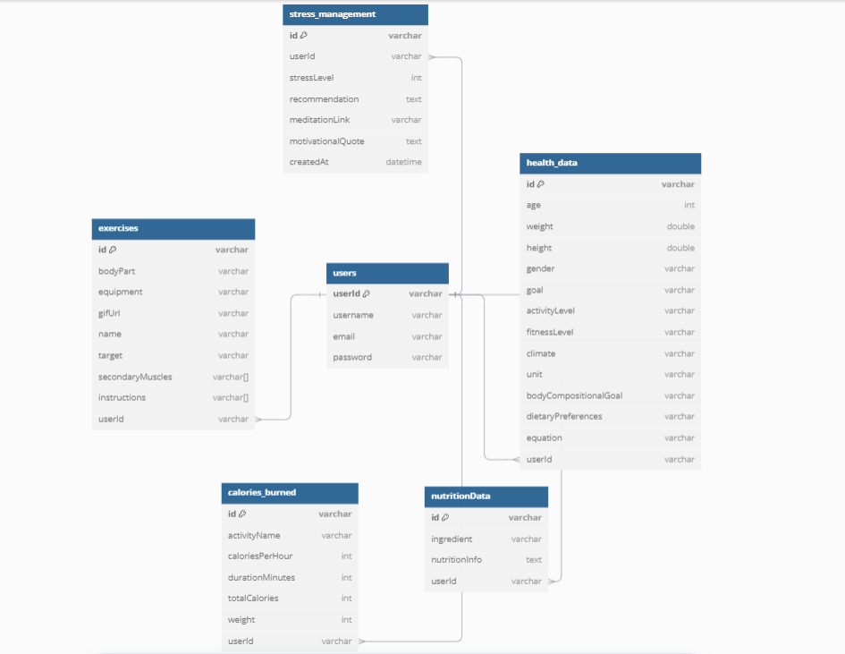

**Output Screenshots:**

1. Dashboard

